Highlights of Preplacement Training:

S No | Batch | Branch | Total Strength | Students Registered | Students Placed | %
1 | 2014-18 | CSE | 170 | 110 | 102 | 92.72
1 | 2014-18 | ECE | 172 | 100 | 95 | 95
1 | 2014-18 | EEE | 59 | 29 | 26 | 89.65
1 | 2014-18 | IT | 15 | 13 | 10 | 76.92
1 | 2014-18 | ME | 32 | 14 | 14 | 100
2 | 2015-19 | CSE | 183 | 137 | 136 | 99.27
2 | 2015-19 | ECE | 184 | 67 | 65 | 97.01
2 | 2015-19 | EEE | 86 | 33 | 33 | 100
2 | 2015-19 | IT | 49 | 29 | 29 | 100
2 | 2015-19 | ME | 49 | 16 | 15 | 93.75
3 | 2016-20 | CSE | 189 | 135 | 135 | 100
3 | 2016-20 | ECE | 193 | 96 | 94 | 97.91
3 | 2016-20 | EEE | 118 | 62 | 54 | 87.09
3 | 2016-20 | IT | 49 | 28 | 28 | 100
3 | 2016-20 | ME | 46 | 8 | 8 | 100
4 | 2017-21 | CSE | 195 | 143 | 127 | 88.81
4 | 2017-21 | ECE | 196 | 140 | 125 | 89.28
4 | 2017-21 | EEE | 121 | 79 | 62 | 78.48
4 | 2017-21 | IT | 54 | 40 | 39 | 97.5
4 | 2017-21 | ME | 37 | 11 | 8 | 72.7
5 | 2018-22 | CSE | 192 | 151 | 143 | 94.70
5 | 2018-22 | ECE | 182 | 123 | 118 | 95.93
5 | 2018-22 | EEE | 107 | 51 | 51 | 100.00
5 | 2018-22 | IT | 53 | 43 | 43 | 100.00
5 | 2018-22 | ME | 38 | 10 | 8 | 80.00
6 | 2019-23 | CSE | 196 | 164 | 82 | 50
6 | 2019-23 | ECE | 175 | 147 | 52 | 35.37
6 | 2019-23 | EEE | 76 | 42 | 9 | 21.43
6 | 2019-23 | IT | 58 | 51 | 20 | 39.22
6 | 2019-23 | ME | 21 | NA | NA | NA

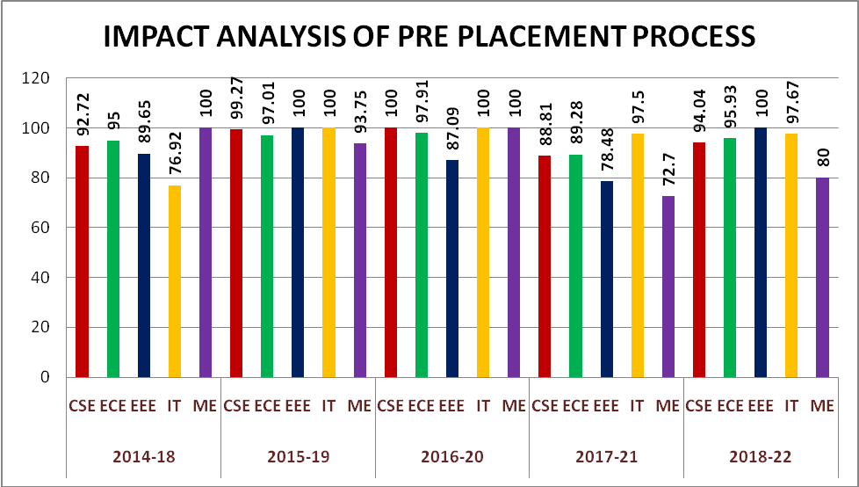

Highlights of Placement Process & Support:

S No | Batch | Branch | Total Strength | Final Placements | % Placed
1 | 2014-18 | CSE | 170 | 142 | 83.52
1 | 2014-18 | ECE | 172 | 137 | 79.65
1 | 2014-18 | EEE | 59 | 47 | 79.66
1 | 2014-18 | IT | 15 | 10 | 66.67
1 | 2014-18 | ME | 32 | 22 | 68.75
2 | 2015-19 | CSE | 183 | 165 | 90.16
2 | 2015-19 | ECE | 184 | 144 | 78.26
2 | 2015-19 | EEE | 86 | 67 | 77.9
2 | 2015-19 | IT | 49 | 35 | 71.42
2 | 2015-19 | ME | 49 | 38 | 77.55
2 | 2015-19 | MBA | 83 | 2 | 2.4
3 | 2016-20 | CSE | 189 | 153 | 80.95
3 | 2016-20 | ECE | 193 | 154 | 79.79
3 | 2016-20 | EEE | 118 | 75 | 63.56
3 | 2016-20 | IT | 49 | 24 | 48.98
3 | 2016-20 | ME | 46 | 22 | 47.83
4 | 2017-21 | CSE | 195 | 168 | 86.15
4 | 2017-21 | ECE | 196 | 169 | 86.22
4 | 2017-21 | EEE | 121 | 104 | 85.95
4 | 2017-21 | IT | 54 | 47 | 87.04
4 | 2017-21 | ME | 37 | 27 | 72.97
5 | 2018-22 | CSE | 192 | 172 | 89.58
5 | 2018-22 | ECE | 182 | 162 | 89.01
5 | 2018-22 | EEE | 107 | 97 | 90.65
5 | 2018-22 | IT | 53 | 50 | 94.34
5 | 2018-22 | ME | 38 | 34 | 89.47
5 | 2018-22 | MBA | 49 | 18 | 36.73
5 | 2019-23 | CSE | 192 | 82 | 42.71
5 | 2019-23 | ECE | 182 | 52 | 28.57
5 | 2019-23 | EEE | 107 | 9 | 8.41
5 | 2019-23 | IT | 53 | 20 | 37.74
5 | 2019-23 | ME | 38 | 0 | 0.00
5 | 2019-23 | MBA | 69 | 3 | 4.35
OVERALL: |  |  | 3542 | 2451 | 69.12

